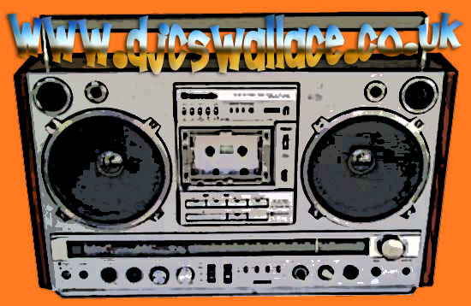

Chilled out and Funky mix

Dj shadow – blood on the motorway
Sly and the family stone – remember
(dj cs Wallace remix)
Black science orchestra - emancipation
Philadelphia experiment - grover
3rd bass - monte hall
leon haywood - I wanna do something freaky to you
detroit experiment - think twice
max sedgeley - happy people
manbreak - round and round
big muff - feel what you know
the rolling stones - sympathy for the devil
jungle brothers - doin our own dang
air – la femme d’argent
mondo grosso – soufflés
loleatta Holloway – love sensation

Email: djcswal@yahoo.co.uk

